There’s a great big town…
on a great big lake…called
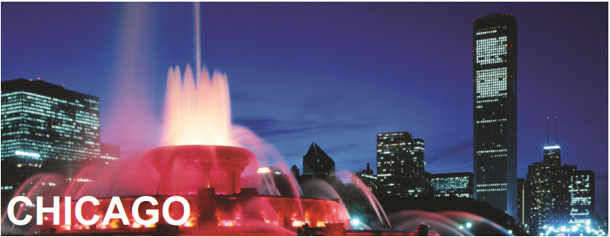
Join us on the first-ever all PAC trip! Spring Break, 2015 (March 27-April 1)
Trip will include: Airfare to and from Chicago, Hotel for 4 nights, Breakfasts and Dinners, Ground transit once we’re in Chicago
SHOWS: a Musical (The Book of Mormon is playing there then!), Chicago Symphony Orchestra, Hubbard Street Dance Company (or other comparable dance presentation), a play, possibly one more concert/show.
Chicago Highlights: Chicago Art Institute, Chicago Architecture Foundation tour, and more!
Cost: Approx. $1700 (and maybe less!)
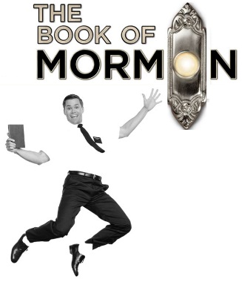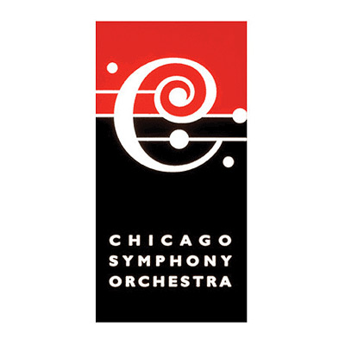
YES! I want to go to Chicago! My $100 deposit is due this Friday, June 13!
Name: _________________________________________________________________
Parent Name: _________________________________________ Phone: ____________________
Parent Email: ________________________________________
Student Email: ________________________________________
A deposit of $100 secures your place on this trip! Bring this form and your payment receipt to your teacher after you’ve paid the bookkeeper, and we’ll put you on the trip! More information at a parent meeting coming next week!

